OOP Lab: Experiment 2

Submitted By: Aryan Saxena

Batch: B1

SAP Id: 500082431

Roll No.: R214220274

**Exercise 1:** Write a program to find the largest of 3 numbers.

## Code:

import java.util.*;

public class Largestof3 {

    void threeNumbers(int a, int b, int c){

        int temp;

        if(a>=b)

            temp=a;

        else

            temp=b;

        if(temp>=c)

            System.out.println("Largest Number: "+temp);

        else

        System.out.println("Largest Number: "+c);

    }

    public static void main(String[] args)

    {

        Scanner sc=new Scanner(System.in);

        System.out.print("Enter first number: ");

        int a= sc.nextInt();

        System.out.print("Enter second number: ");

        int b= sc.nextInt();

        System.out.print("Enter third number: ");

        int c= sc.nextInt();

        Largestof3 obj = new Largestof3();

        obj.threeNumbers(a,b,c);

        sc.close();

    }

}

## Output:

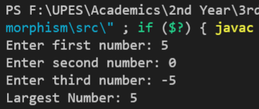

**Exercise 2:** Write a program to implement a command line calculator. (Try for Add sub Mul Division in same program for 2 digits.)

## Code:

public class CL_Calculator {

    void Calc(int x, String c, int y)

    {

        int Output;

        switch (c)

        {

            case "+":

                Output= x+y;

                System.out.println(x + c + y + "= "  + Output);

                break;

            case "-":

                Output= x-y;

                System.out.println(x + c + y + "= "  + Output);

                break;

            case "*":

                Output= x*y;

                System.out.println(x + c + y + "= "  + Output);

                break;

            case "/":

                Output= x/y;

                System.out.println(x + c + y + "= "  + Output);

                break;

            default:

                System.out.println("Wrong Input!");

                break;

        }

    }

    public static void main(String args[])

    {

        int x=Integer.parseInt(args[0]);

        int y=Integer.parseInt(args[2]);

        CL_Calculator obj = new CL_Calculator();

        obj.Calc(x, args[1], y);

    }

}

## Output:

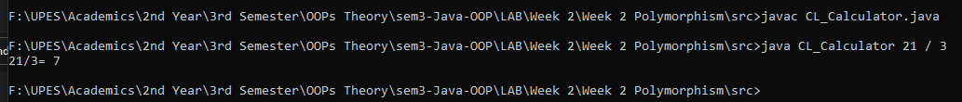

**Exercise 3:** Write a program to accept 10 student’s marks in an array, arrange it into ascending order, convert into the following grades and print marks and grades in the tabular form.

## Code:

import java.util.Scanner;

public class Marks {

    public static void arraysort(float[] arr)

    {

        float temp = 0;

        for(int i=0;i<arr.length;i++)

        {

            for(int j=i+1;j<arr.length;j++)

            {

                if(arr[i]>arr[j])

                {

                    temp = arr[i];

                    arr[i]=arr[j];

                    arr[j]=temp;

                }

            }

        }

    }

    void Report(float[] arr)

    {

        //System.out.println("Enter Marks: \n");

        Scanner sc = new Scanner(System.in);;

        for(int i=0;i<arr.length;i++)

        {

            System.out.println("Enter Marks of Student " + (i+1) + " : ");

            arr[i]= sc.nextInt();

        }

        sc.close();

        arraysort(arr);

        System.out.println("\n-------Report-------\n");

        for(int i=0;i<arr.length;i++)

        {

            if(arr[i]>75)

                System.out.println(arr[i] + ": DISTINCTION");

            else if(arr[i]>=51 && arr[i] <= 75)

                System.out.println(arr[i] + " MERIT");

            else if(arr[i]>=40 && arr[i] <= 50)

                System.out.println(arr[i] + " PASS");

            else

                System.out.println(arr[i] + " Fail");

        }

    }

    public static void main(String[] args)

    {

        float marksarray[];

        marksarray = new float[10];

        Marks obj = new Marks();

        obj.Report(marksarray);

    }

}

## Output:

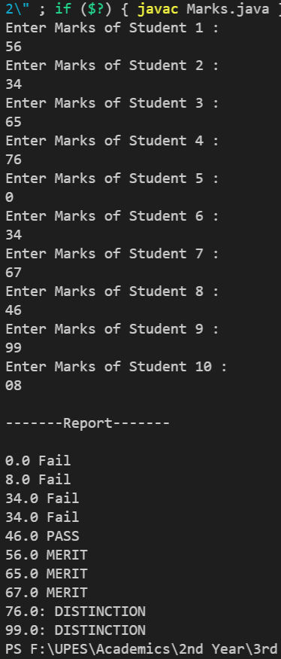

**Exercise 4:** WAP to Take input as DD MM YYYY(04 08 2021) incommand line and calculate number of days since 1 January 1970.

## Code:

public class lab2_Days

{

    public static void main(String args[])

    {

        int d = Integer.parseInt(args[0]);

        int m = Integer.parseInt(args[1]);

        int y = Integer.parseInt(args[2]);

        int monthDays[] = {31, 59, 90, 120, 151, 181, 212, 243, 273, 304, 334, 365};

        int dyear = y - 1970;

        int x, num = 0;

        for(x = 1970; x<=y; x++)

        {

            if(x%4 == 0 && x%400 == 0 && x%100 != 0){

                num++;

            }

        }

        int days;

        days = dyear*365 + monthDays[m-2] + d + num;

        System.out.println("Total days = " + days);

    }

}

## Output:

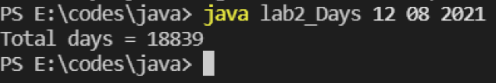

**Exercise 5: WAP** to print the following pattern using loops

**\***

**\*\***

**\*\*\***

## Code:

public class Pattern

{

    void printpattern()

    {

        int n=3;

        for(int i=0; i<n; i++)

        {

            for(int j=0; j<(2*i+1); j++)

            {

                System.out.print("*");

            }

            System.out.println("\n");

        }

    }

    public static void main(String[] args)

    {

        Pattern obj = new Pattern();

        obj.printpattern();

    }

}

## Output:

